**1.stdio.h**

Ans:This header file used to print and read the input and output in the program.

**2.time.h**

Ans:This header file is used to display time in the program it has many types to display but we have choosed time(&)(it returns the time since unix stamp(0.00 utc 1970 jan 1st)

**3.stdlib.h**

Ans:This header file is used because we have used the random function in our food menu so this file helps in generating random number and also it helps in other functions used in the program.It also consists the header file of string in it(i.e:the string functions included in it.)

**4.structure:**

Ans:The main reason to use structure is it can store heterogenous data type in it as a single unit.The keyword or syntax to start structure is **struct**

**Body:**

**Struct nameofstruct**

**{**

**Body of the structure**

**} variable of struct;**

**5.Global variables:**These global variables are used or can be used in all over the program.

**6.void main():**it is a function with no argument and no return value.

**7.aread(); :**this is a user defined function used to read the previous data written in the function.(it consists of train details.)

**8.viewpassengers_read(); :**this is a user defined function used to read the the previous data written in the function.(it consists of passenger details.)

**9.Maximum of 8 tabspaces(\t) can be used in a single line.**

**10.Total user defined functions=18 they are:**

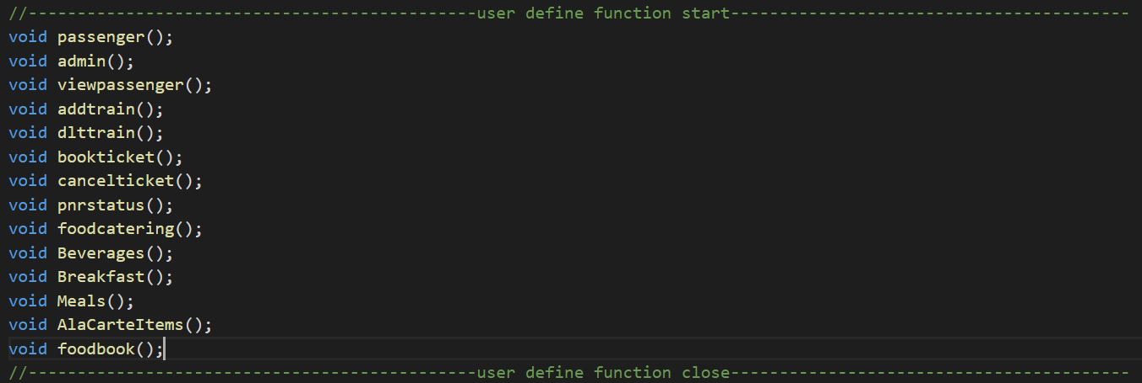

void awrite()

void aread()

void bookticket_write()

void viewpassengers_read()

**11.time_t t; :**This is a datatype in c library defined for storing the system time values.

**12.time(&t); :**This function returns the time since unix timestamp in seconds.

**13.ctime(&t); :**This functions displays the constant time.

**14.system(“clear”); :**it clears the console.

**15.switch case:** the switch allows to excute one code block among many alternatives

* If we do not use the break statement, all statements after the matching label are also executed.
* The default clause inside the switch statement is optional.
* the [break statement](https://www.programiz.com/c-programming/c-break-continue-statement) terminates the switch statement and moves control to the next case.
* If there is no match, the default statements are executed.

**16.getchar(); :**function that reads a character from **standard input**.

**17.if statement:**if the test value inside the paranthesis is true the statements inside the body of the if are excuted.otherwise it exits the case and it goes else(if it is there) and prints the statements inside the else.

**18.for loop:**

for (initializationStatement; testExpression; updateStatement)

{

// statements inside the body of loop

}

* The initialization statement is executed only once.
* Then, the test expression is evaluated. If the test expression is evaluated to false, the for loop is terminated.
* However, if the test expression is evaluated to true, statements inside the body of the for loop are executed, and the update expression is updated.
* Again the test expression is evaluated.

This process goes on until the test expression is false. When the test expression is false, the loop terminates.

**19.awrite(); :** this is a user defined function used to write the data which is read from the user in the function.(it consists of train details.)

**20.strcmp:**it is used to compare two strings.

**21.strcpy:**it is used to copy two strings.

**22. bookticket_write(); :** this is a user defined function used to write the data which is read from the user in the function.(it consists of passenger details.)

**23.srand(seed):** srand() sets the seed which is used by rand to generate “random” numbers. If you don’t call srand before your first call to rand, it’s as if you had called srand(1) to set the seed to one.

In short, **srand() — Set Seed for rand() Function**.

**24.rand():** it is a predefined function used to create random numbers and prints on the output screen.

**25.Explanation of terms in file handling:**

FILE *booklist;

**Declaring the file pointer**

booklist = fopen("booklist.txt", "w");

booklist is a pointer of the FILE data type, which references the opened or newly created file.

Opening a file is performed using the fopen() function defined in the stdio.h header file and “w” indicates to Open for writing.

fwrite(&book, sizeof(book), 1, booklist);

Functions fread() and fwrite() are used for reading from and writing to a file on the disk respectively in case of binary files.

fwrite(addressData, sizeData, numbersData, pointerToFile);

**&book: it Is the address of data to be written on the disk.**

**Sizeof(book): size of data to be written in disk.**

**1:number of such type of data.**

**Booklist:pointer to the file where you want to write.**

fclose(booklist);

Closing a file is performed using the fclose() function.